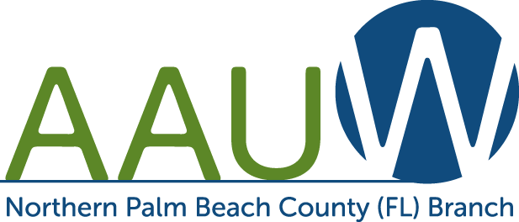
Empowering Women Since 1881

Scholarship Application Information for scholarships from the Northern Palm Beach Branch of AAUW. Application Deadline is March 20, 2021 There is no fee to apply.
Two Scholarships are available:
The Doris Karlik Scholarship is for women only and ranges from $500.00 to $1,500.00.
The Scholarship to Honor the North Palm Beach Library Friends is for women or men and is for $2,500.00

Requirements:
- Resident of Palm Beach County, FL. (For the Scholarship to Honor Friends of the North Palm Beach Library, recipient must be a resident of Lake Park, North Palm Beach, or Riviera Beach FL.
- US Citizen, by birth or naturalization.
- Attending an accredited Florida college, university, or trade school. (For the Scholarship to Honor Friends of the North Palm Beach Library, field of study may be Liberal Arts, Science, Technology, Engineering, Mathematics or a trade (at an accredited trade school).
- 3.0 grade point average or higher.
- Submit a completed application form including personal statements (see page two).
- Submit an OFFICIAL college transcript with your application.
- Provide two (2) letters of recommendation, one from a college or university faculty member acquainted with your work on official letterhead and signed. Letters of recommendation may also be submitted by recommender as a PDF to AAUWNPBC@gmail.com

ALL MATERIALS MUST BE POSTMARKED BY U.S. MAIL BY MARCH 20, 2021.

Grade point averages and funding sources will be verified before final awards are made. Personal interviews may be required by the scholarship committee. Awards will be made based on GPA, written personal statement of career goals, demonstrated financial need, family responsibilities, and letters of reference. Recipients will be announced in April. Scholarship funds will be available beginning with the fall semester of the 2020-2021 school year.

All application materials are for internal use only. No information will be shared with any other organization.

Send Completed AAUW Scholarship Committee
Application To: P.O. Box 32043
Palm Beach Gardens, FL 33420

For Scholarship Application go to: http://northernpalmbeach-fl.aauw.net

The Goal of AAUW
AAUW (American Association of University Women) advances equity for women and girls through advocacy, education, philanthropy, and research, so all women have a fair chance in any endeavor.
Application for the Doris Karlik Scholarship _________Check here
Application for Scholarship to Honor Friends of the North Palm Beach Library _______Check here
Palm Beach County Residents Only
Amount of Award $500-$2,500 Deadline is March 20, 2021

Name: __________________________________________________ Student ID#: ____________________
Address: _______________________________________________________________________________
Street City County Zip Code
Cell Phone: _______________________________ Email: _________________________________
Date of Birth: ______________________________ Place of Birth ____________________________
Marital Status: _____________________________ No of Children: _______ Ages: _____________
U.S. Citizen: _____Yes _____ No Naturalization Date: ______
I will be a:_____ Sophomore_____ Junior _____ Senior Expected Graduation Date: _________________
College Major: _____________________________ College Minor: __________________________
GPA: _______ Credit Hours completed to date: _____________
College/University where scholarship funds will be used: _________________________________________
Previous Education: School Location Years Attended Graduation Date
High School_____________________________________________________________________________
Community College/College ________________________________________________________________
Volunteer Work __________________________________________________________________________
_______________________________________________________________________________________
Employment history________________________________________________________________________
- In 200 words or less, please attach a personal statement including your career goals, and how you plan to achieve your goals.
- In 200 words or less, please attach a statement of why you need a scholarship. Include current resources (i.e. means of support, employment status, unusual circumstances, funding sources). List dollar amounts received for scholarships, assistantships, grants, other money sources (including amount of college loans).
- Include two (2) current letters of reference (one must be from a faculty member: on official letterhead and signed) and an official transcript from your college or university.

- Attach Official College Transcript.

I authorize the release of this application and any supporting information involved in the selection of scholarship recipients.

_________________________________________________________________________________________________________ Signature Date

