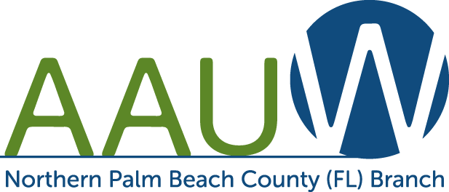
Empowering Women Since 1881

Scholarship Application Information for scholarships from the Northern Palm Beach Branch of AAUW. Application Deadline is March 25, 2022. There is no fee to apply.

The Doris Karlik Scholarship for Women ranges from $500 to $1,500.

Requirements:
- Resident of Palm Beach County, FL.
- US Citizen, by birth or naturalization.
- Attending or planning to attend an accredited Florida college, university, or trade school.
- 3.0 grade point average or higher (For high school seniors, your high school GPA. For college students, your college GPA only).
- Submit a completed application form including personal statements (see page two).
- Submit an unofficial college (or high school if you are a high school senior) transcript with your application.

ALL MATERIALS MUST BE POSTMARKED BY U.S. MAIL BY MARCH 25, 2022.

Grade point averages and funding sources will be verified before final awards are made. Personal interviews may be required by the scholarship committee. Awards will be made based on GPA, written personal statement of career goals, demonstrated financial need and family responsibilities. Recipients will be announced in April. Scholarship funds will be available beginning with the fall semester of the 2022-2023 school year.

All application materials are for internal use only. No information will be shared with any other organization.

Send Completed AAUW Scholarship Committee
Application To: P.O. Box 32043
Palm Beach Gardens, FL 33420

For Scholarship Application go to: http://northernpalmbeach-fl.aauw.net

The Goal of AAUW
AAUW (American Association of University Women) advances equity for women and girls through advocacy, education, philanthropy, and research, so all women have a fair chance in any endeavor.

Amount of Award $500-$2,500 Deadline is March 25, 2022

Name: _____________________________________________College Student ID#: ____________________
Address: _______________________________________________________________________________
Street City County Zip Code
Cell Phone: _______________________________ Email: _________________________________
Date of Birth: ______________________________ Place of Birth ____________________________
Marital Status: _____________________________ No of Children: _______ Ages: _____________
U.S. Citizen: _____Yes _____ No Naturalization Date: ______
I will be a:_____ Freshman _____Sophomore_____ Junior _____ Senior Expected Graduation Date: _____
College Major: _____________________________ College Minor: __________________________
GPA: _______ Credit Hours completed to date: _____________
College/University where scholarship funds will be used: _________________________________________
Previous Education: School Location Years Attended Graduation Date
High School_____________________________________________________________________________
Community College/College ________________________________________________________________
Volunteer Work __________________________________________________________________________
_______________________________________________________________________________________
Employment history________________________________________________________________________
- In 300 words or less, please attach a personal statement including your career goals, and how you plan to achieve your goals.
- In 300 words or less, please attach a statement of why you need a scholarship. Include current resources (i.e. means of support, employment status, unusual circumstances, funding sources). List dollar amounts received for scholarships, assistantships, grants, other money sources (including amount of college loans).
- Attach unofficial College or High School (if a high school senior) transcript.

I authorize the release of this application and any supporting information involved in the selection of scholarship recipients.

_________________________________________________________________________________________________________ Signature Date

